**Screenshot Outputs for Project 1:**

**1:** This shows the categories being added into the program.

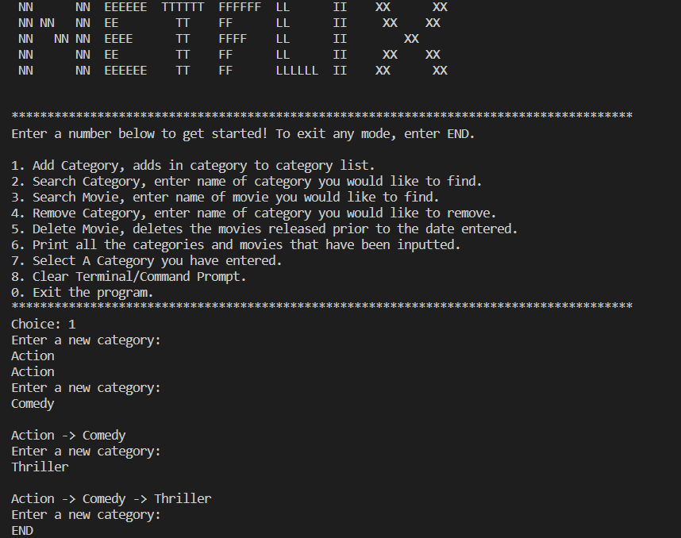

**2:** This part will check if the categories exist in the program.

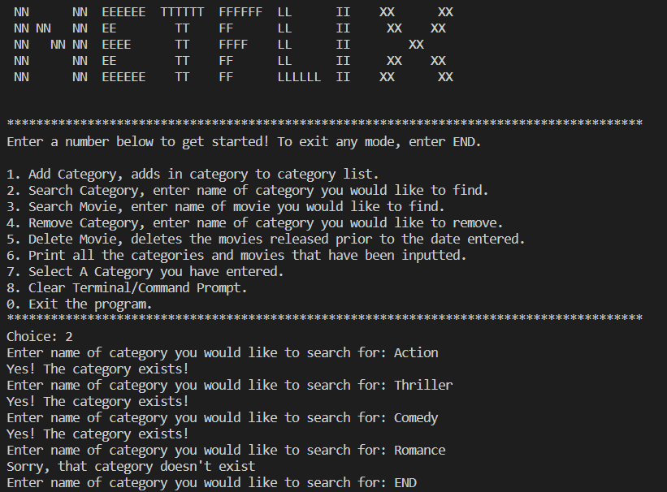

**3:** This is the section where the user inputs the movies and their release dates.

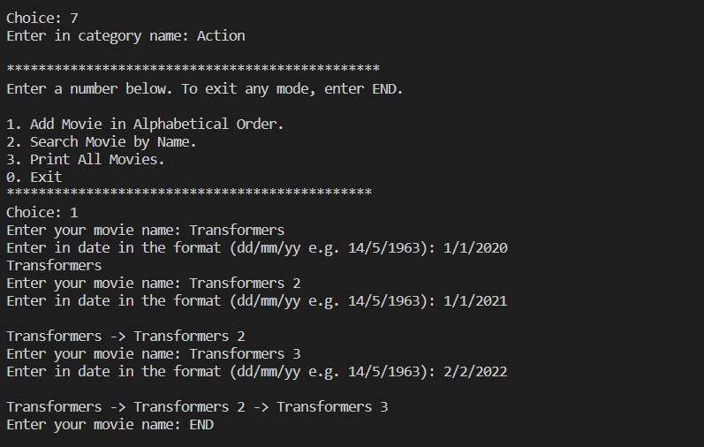

**4:** This section checks if the movie exists in its respective category.

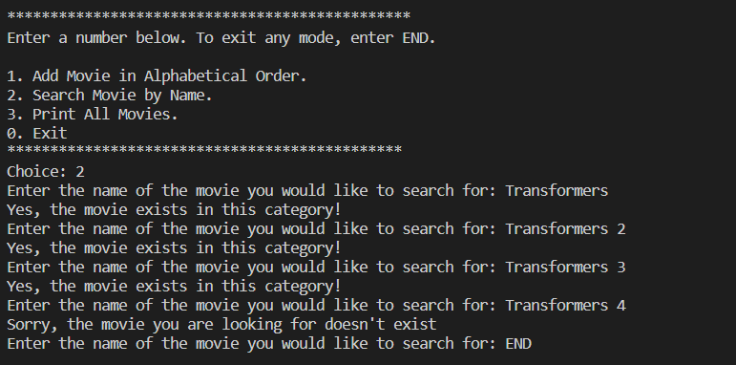

**5:** Prints out the movies inputted in the respective categories.

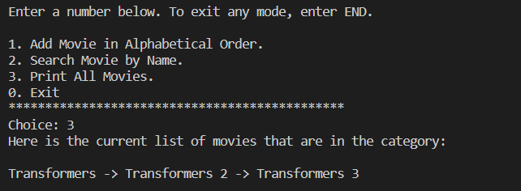

**6:** This section searches the different movies that have been stored in different categories and prints its index accordingly.

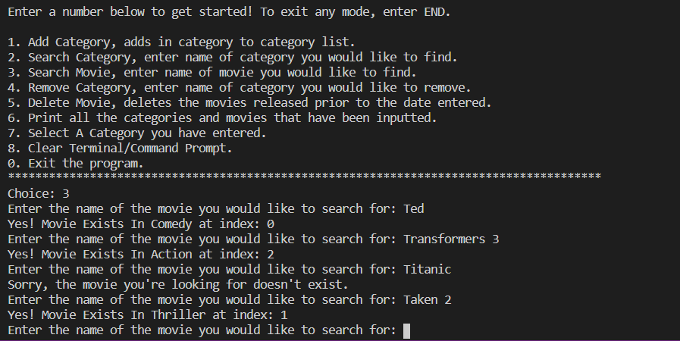

**7:** This part allows the user to remove a category and the movies stored within that category.

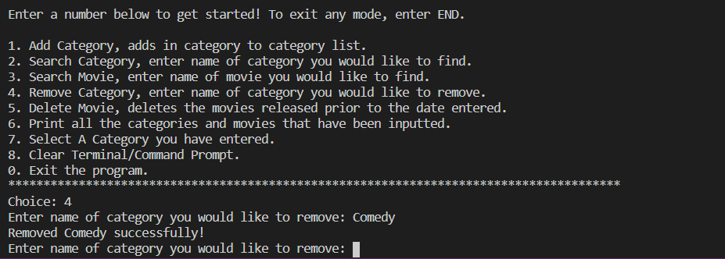

**8:** This part will delete a movie prior to the date the user inputs.

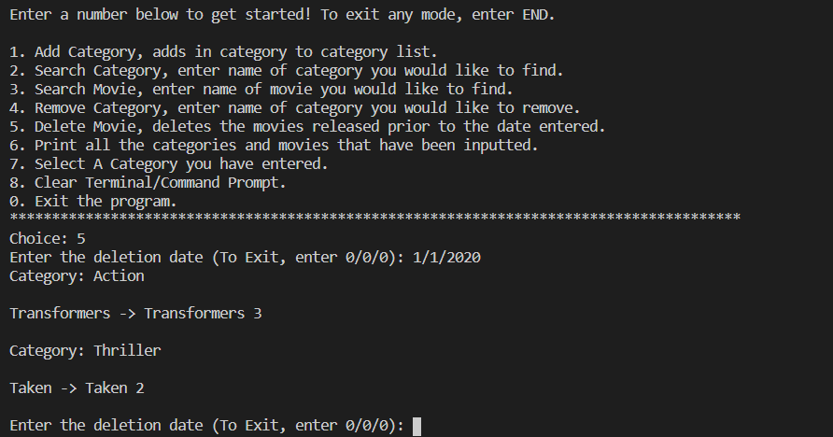

**9:** This part prints all the current categories along with their movies.

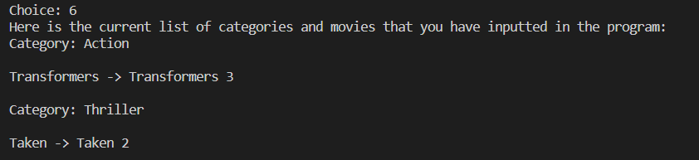

**10:** Entering 0 on the main menu will exit the entire program.

